BigData Hadoop and Hive Assignment - 1
Query - 0 : Put dataset on HDFS and explore it through Hive.

- Created EpamTask Database on Hive

Hive > Create database Epamtask;
Hive > Show Databases;



- Physical path of Databases on VMs

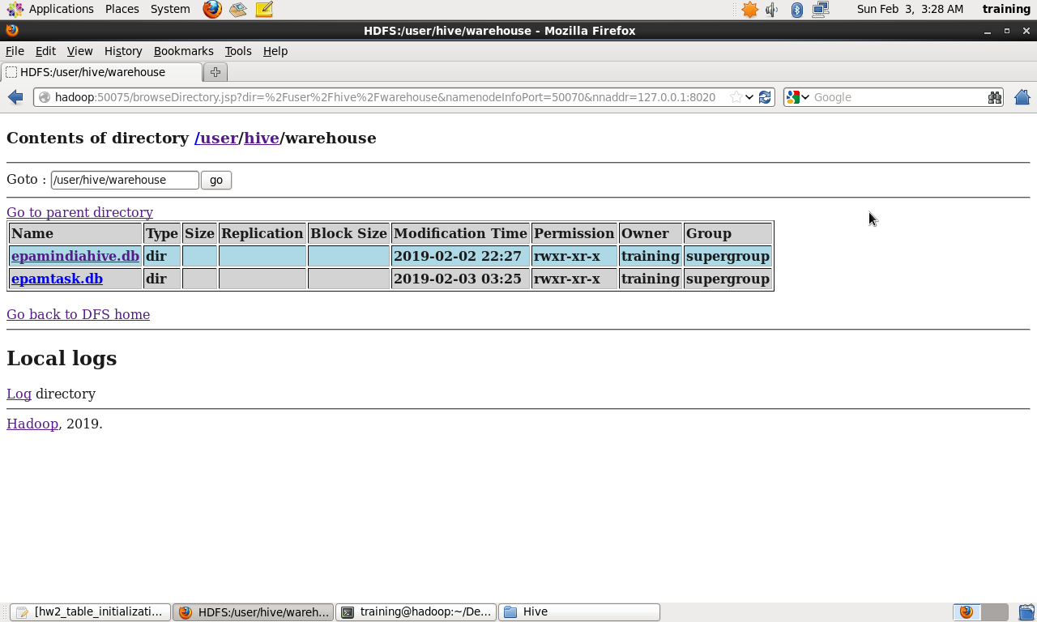

- Crated table Airports
Hive > Create table Airports((iata string, airport string, city string, state string,country string,lat float,long float) row format delimited fields terminated by ‘,’ lines terminated by ‘\n’ ;

Hive > desc formatted Airports;

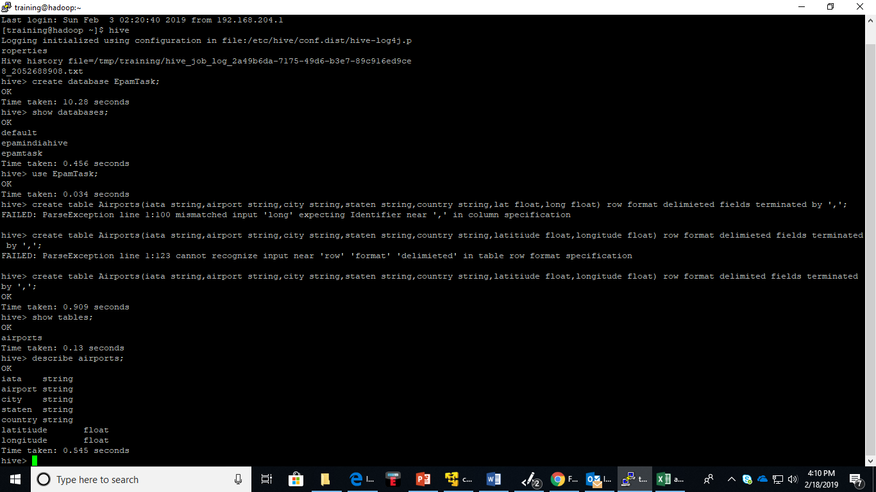

- Load airports.csv file data to Airtports table from hdfs
Hive > load data inpath ‘/user/home/hdfs/hiveip/Airports.csv’ into table ariports ;
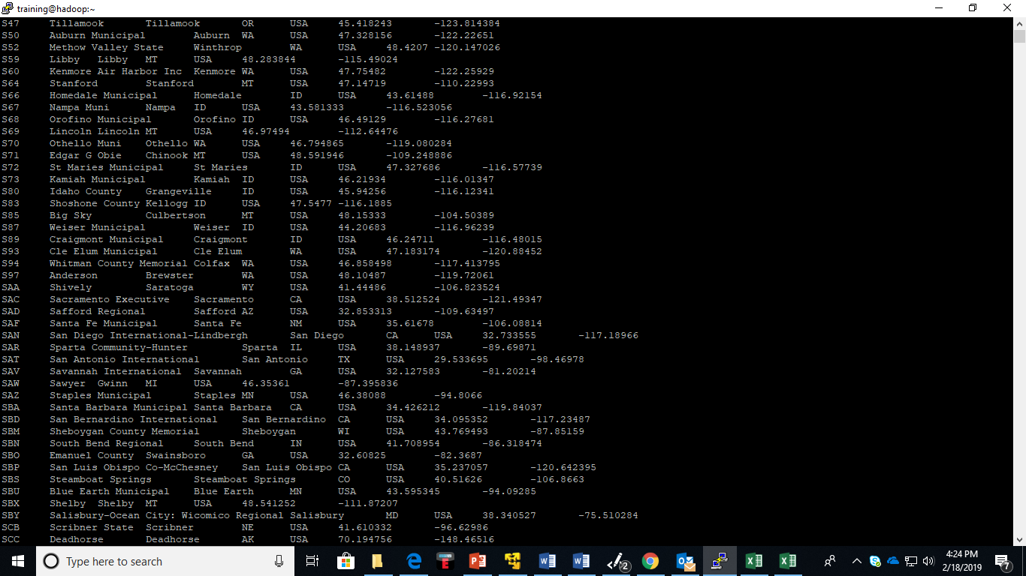

- Create Carriers table and load Carrier.CSV file in to Carriers table

Hive > load data inpath ‘/user/home/hdfs/hiveip/Carriers.csv’ into table ariports ;



- Create Flying table and load Flights.csv file to Flying data table.

Hive > load data inpath ‘/user/home/hdfs/hiveip/Flights.csv’ into table Flying ;

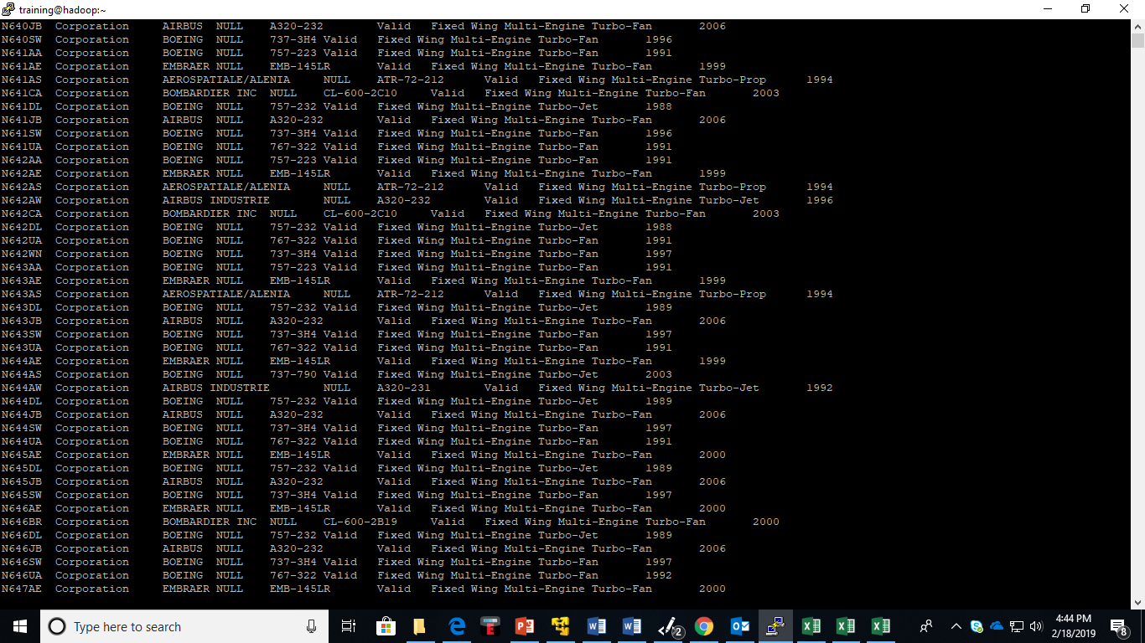
- Physical path of Hadoop tables(airports, planes and carries) on hive/EpamTask database
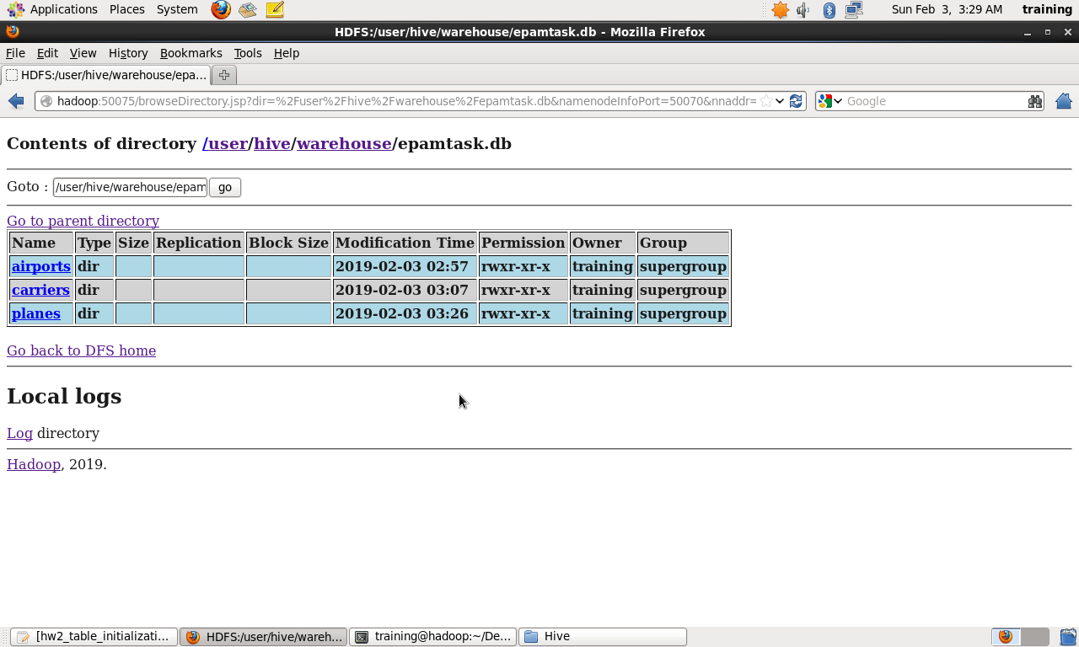

- Files moved to HDFS from VM/local machine

Terminal > Hadoop fs -put departments.txt hdfsjan26/hiveip/
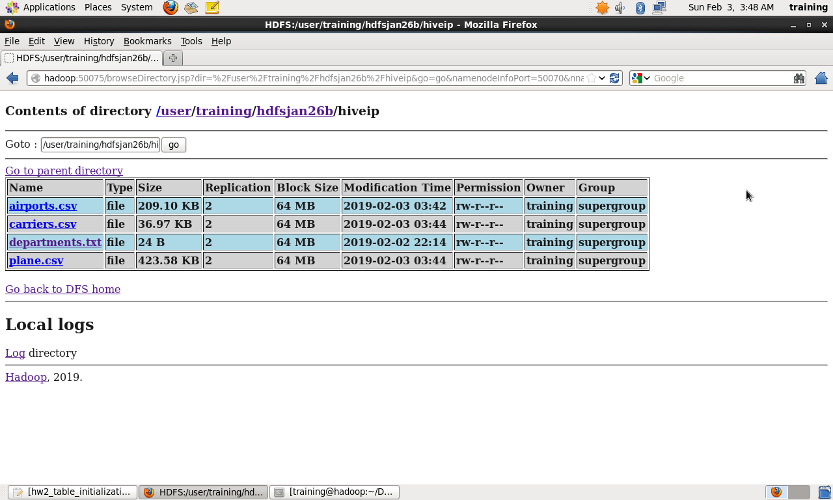

Query -1 : Count total number of flights per carrier in 2007

SELECT c.description as carrier, COUNT(f.UniqueCarrier) as count from flying f inner join carriers c ON f.UniqueCarrier=c.code GROUP BY(c.description) limit 100;

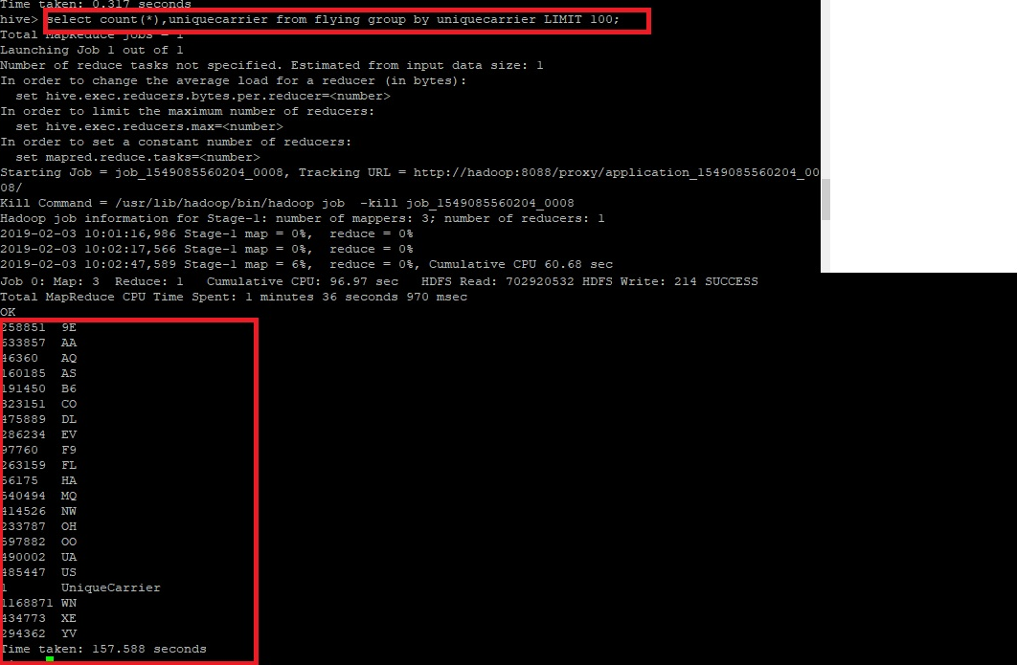

Query -2 : The total number of flights served in Jun 2007

select count(f.origin),a1.iata from flying f inner join airports a1 ON f.Origin=a1.iata inner join airports a2 ON f.dest=a2.iata where f.Month=6 group by a1.iata;
Output :

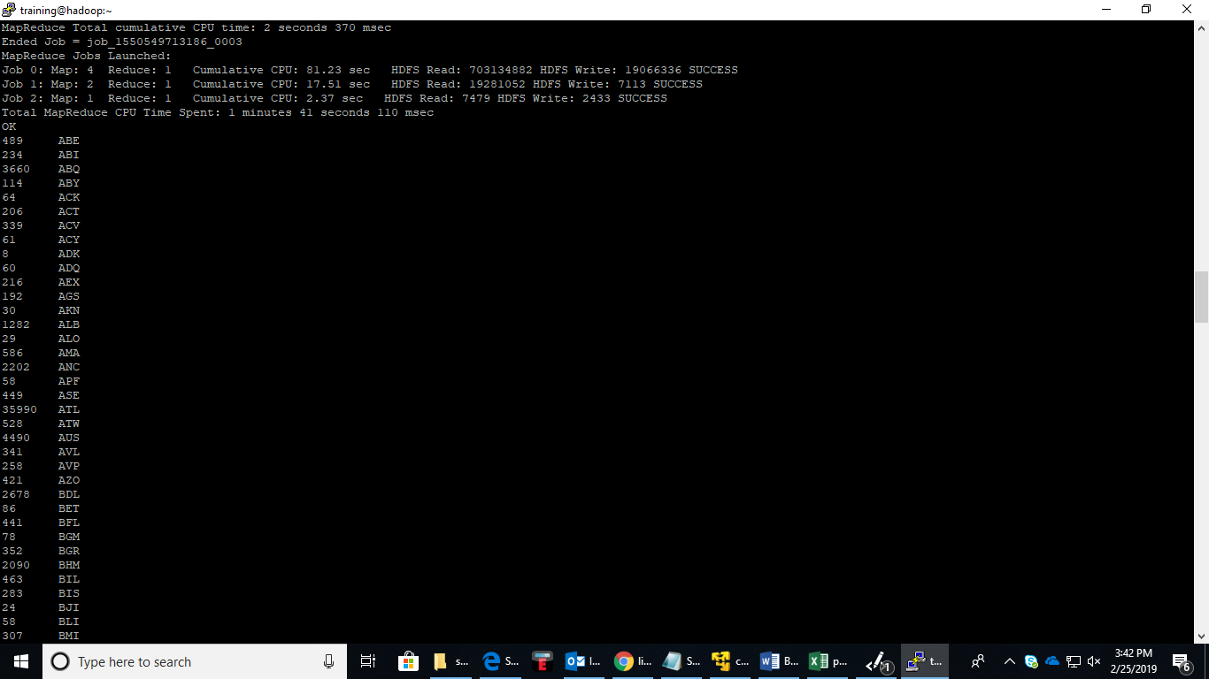

Query – 3: Find five most busy airports in US during Jun 01 - Aug 31. (Screanshot#3)

SELECT COUNT(f.Month) c FROM flying f
inner join airports a ON (f.Origin=a.iata)
inner join airports a2 ON (f.Dest=a2.iata)
WHERE a.Dest='USA' and f.Month>5 AND f.Month<9
GROUP BY a.iata
ORDER BY c DESC LIMIT 5;

Note : In 2007 file all records have country = US :

Output :

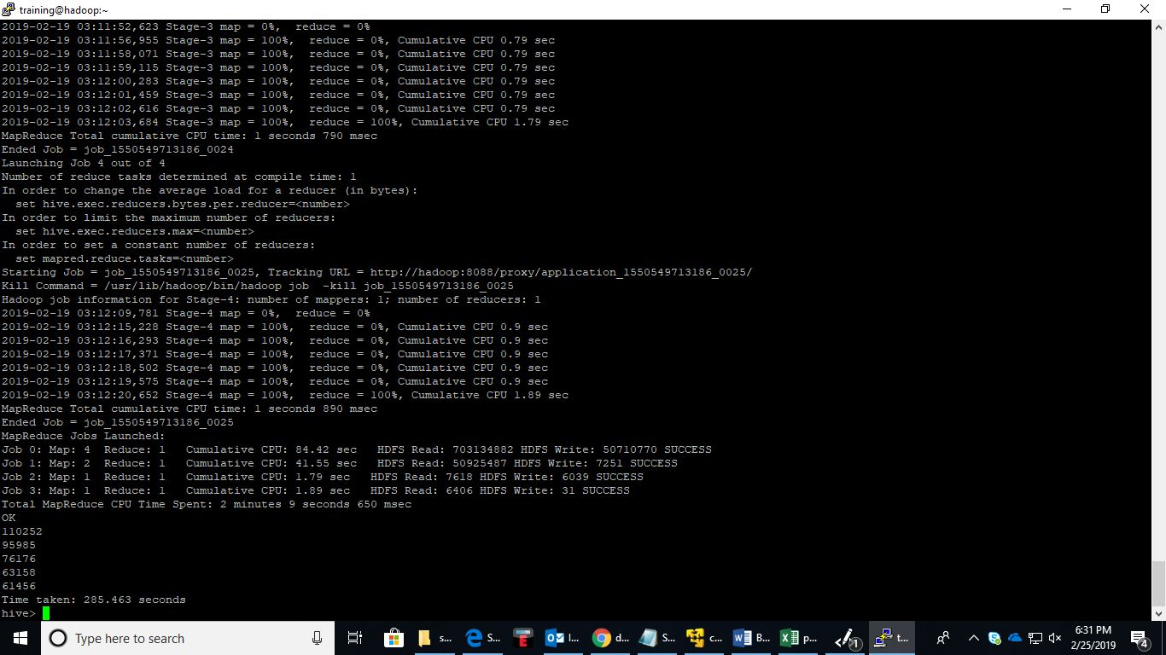

Query -4 : Find the carrier who served the biggest number of flights

Select c.description as carrier, COUNT(f.UniqueCarrier) as count FROM flying f
JOIN carriers c ON f.UniqueCarrier=c.code
GROUP BY(c.description)
ORDER BY count DESC LIMIT 1;

Output :
